Read form data using JavaScript functions

In last week’s hands-on project, we created an online form containing various types. The next question is “how do we get users’ input data from the form?” In this hands-on project, we will learn how to read form data entered by using JavaScript functions.
- Copy the Project Shell into your folder(e.g., Week 2 project). In this folder, you can find three files: one custom.css, one index.html, and another on is validatedForm.html we developed in week 1.
- Open validatedForm.html in your editor. Locate to the <script> </script> block, currently, we only have one window.confirm() statement in the function.

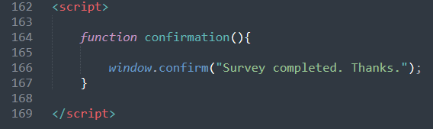

- Firstly, HTML DOM has a method called getElementById(), this is one of the most common methods. It is used all the time when you want to read or edit an HTML element. The method returns an element (object) with a specified value.
- We use getElementById() method to read values from studentID, name,email, phone and comment input fields, and assign the values to variables. (Note variable defined with “let” cannot be redeclared, but “var” can.)
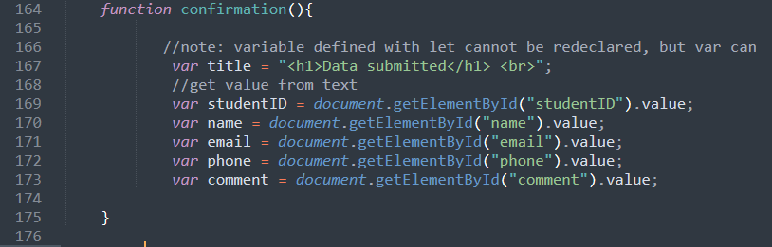
- Using document.wirte() method to display the values received.
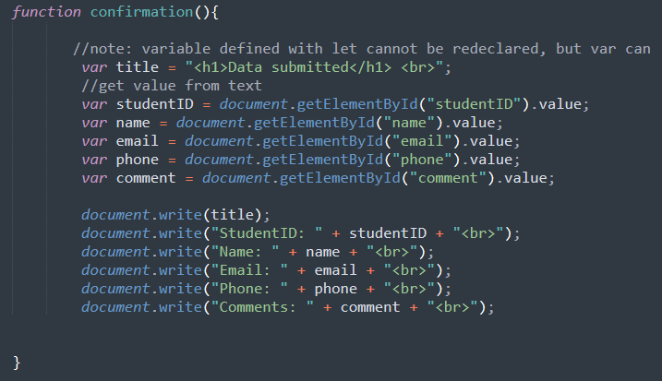

- Save and test with some input values. You should be able to see the following screen. Where the values for StudentID, Name, Email, Phone, and Comment are successfully read.
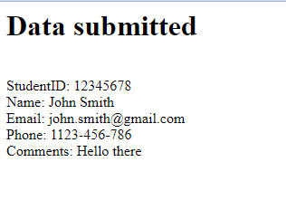
- Next we need to read data from a drop-down list. The element id is “campus”. If we have only one option to be selected, the value can be read straightforward (see below screenshot, line 176 and 185 are added).
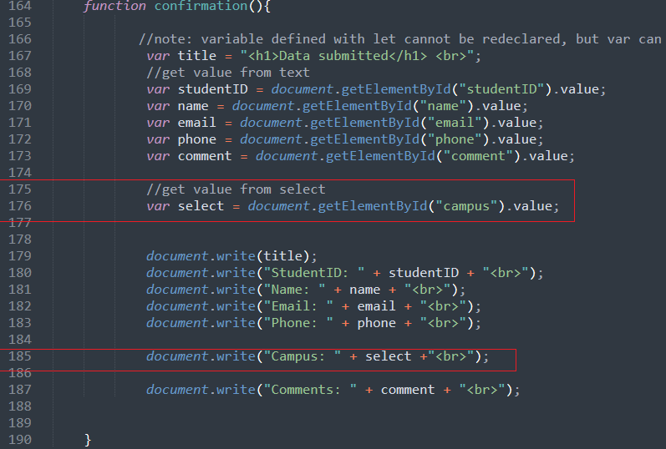
Please note that the drop-down list could have multiple options selected, which need other approaches to read the data. Please refer to references to find more.
- The next step is to read from a radio button group. A radio button group may contain 2 or more radio channels. Only one radio button can be selected at a time. Because we will need to display the real value of the student category rather than a “Yes/No” value, let’s add 2 values to our radio buttons first.
(Tips: It is always a good practice to assign an id, a name and a value to an input element.)

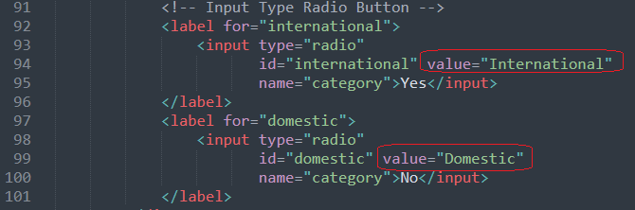

- To read the value from a radio button group, we need to use a for loop to traverse all the radio buttons to find out which is selected. In the next screenshot, we firstly get all elements by tag name “input”, the return type will be like an array list (stored in “ele”), then we use a for loop to check which one is checked, and then assign the value (note this value refer to the value assigned to the radio button in step 8) to the category.

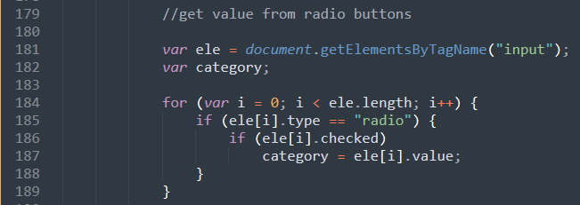

- Add a document.write() (line 200) to display student category. The code for reading from the radio button group will be like this
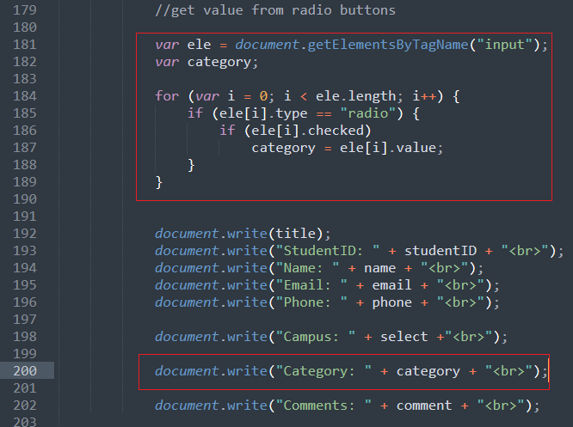

- Save and test with the input data
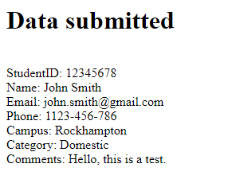

- Looks good! Now we move on to our last element - to read data from checkboxes. Keep in mind that the checkbox type will take multiple input values. We need to use some data structure to hold the retrieved values and display them.
- Study the below code. A checkbox group should have the same name attribute. In our project, it is called “inp” (check code for checkbox input ). Then we can use document.getElementsByName(“inp”) (Line 192), to get the checkbox element. The element is stored in a JavaScript array, the JavaScript array is like an object, which has some methods that we can use to visit the array items (similar to an ArrayList object in Java). Two comment methods are
- “push()” - to add an array element
- “pop()” - to remove the last element from an array

(note: it takes “Stack” data structure )

The following for loop adds all the checked boxes and is pushed in an array “values”.
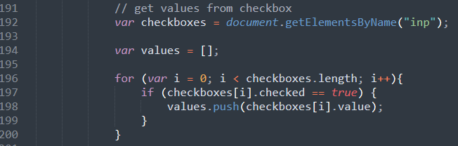

- Finally, display the checked boxes values by using JavaScript Array’s toString( ) method.
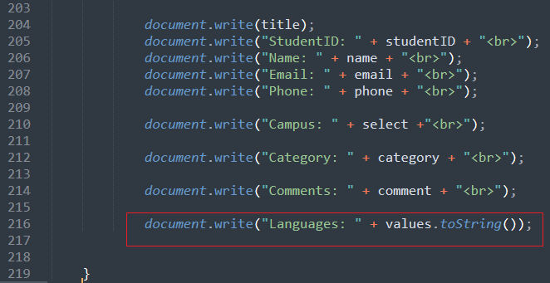

Please note that line 216 must be at the last.
It is tricky that “Using document.write() after an HTML document is loaded, will delete all existing HTML”

- Save and test with appropriate input data.
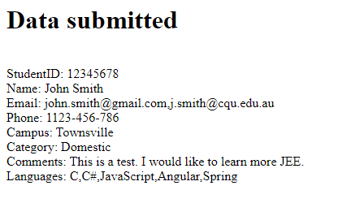

Now all the inputted data are retrieved.

- That completes the Hands-on Project 1.

Reference: https://www.w3schools.com/js/js_input_examples.asp

